 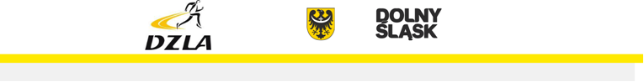

PROGRAM MINUTOWY

7.LUBAWKATHLETICS 30.04.2025[www.dzla.pl](http://www.dzla.pl/)

13.oo 80m ppł U14+U16 (3+1) 1s Kula K (0+4+6)

13.1o 60m K (50 – 9s)

13.4o 60m K U12 (15-3s) Kula M (0+0+5+2)

13.5o 60m M (12-2s)

14.oo 60m K U12 (6-1s)

14.1o 100m K (36-6s)

14.3o 100m M (9-2s) Oszczep K+M (6+5)

14.4o 600m K (15- 2s)

14.5o 600m K U12 (3-1s)

14.55 600m M + U12 (10-1s)

15.05 150m K (9-3s)

15.15 150m M (3-1s)

15.2o 1000m K (5-1s)

15.25 1000m M (6-1s) Piłeczka palantowa K+M (18+3)

15.3o 200m K (11-3s)

15.45 200m K U12 (4-1s)

15.5o 200m M (4-1s)

16.oo 300m K (48-12s)

16.3o 300m K U12 (22-6s)

16.45 300m M (19-5s)

17.oo 300m U12 (3-1s)

17.o5 Chód 1km K (4)

SKOKI DŁUGIE

13.oo W dal K +M ( 5+4)

14.oo W dal K strefa (39)

15.45 W dal M strefa (19)